Metadata

1. Title

Detailed water quality parameters, including methane concentrations and isotopic composition, for groundwater springs discharging from open system pingos in Adventdalen, Svalbard (2015-2017)

1. Abstract

Adventdalen is a medium-sized (513 km2) catchment in continuous permafrost zone of central Spitsbergen. It has 11.7 % glacier cover, a large flat valley floor comprised of uplifted, glaciomarine sediments, covered in the lower part by a veneer of aeolian sediments up to 4 m thick. The geology of the catchment is dominated by sandstones, shales and carbonates. There are a series of five open system pingos that have formed in the valley floor following uplift of the valley bottom over the last 10000 years. This has caused permafrost aggradation in former marine sediments which are up to 60 m thick. During the formation of this new permafrost, high pressure caused expulsion of groundwaters below, resulting in their upward migration. Freezing of the groundwaters as they reached the ground surface caused expansion and thus formation of the pingo. However, freezing no longer occurs at four of the five pingos, meaning that the groundwaters now discharge at the surface. Samples of the emerging groundwaters were collected every March/April, but also opportunistically during summer months, provided the sites weren’t flooded. Analysis of major ions (by ion chromatography), minor constituents (trace metals by icpms and silica by colorimetric analysis) and gases (O2, CO2 and CH4) were undertaken.

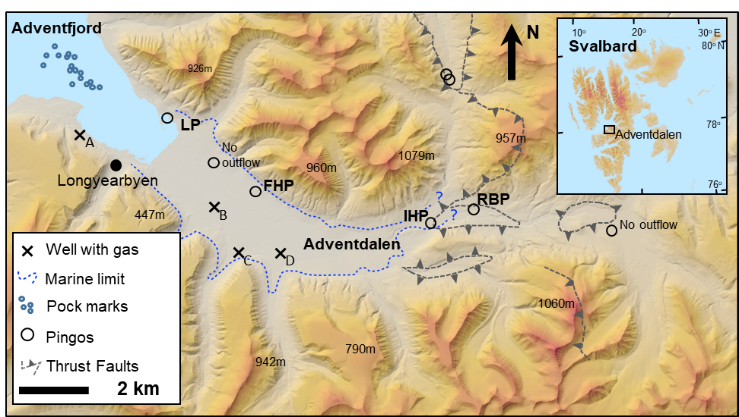

Figure 1. Adventdalen and its open system pingos. Active springs exist at Lagoon Pingo, Førstehytte Pingo, Innerhytte Pingo and River Bed Pingo (LP, FHP, IHP and RBP respectively). Wells A to D are part of the UNIS CO2 Well Park and have provided further information on the sub-permafrost groundwaters (see Braathen et al, 2012, Norwegian Journal of Geology, 92, 353–376). Map developed online at [www.svalbardkartet.npolar.no](http://www.svalbardkartet.npolar.no).

1. Keywords

Pingos, methane, Svalbard, permafrost

1. Lineage/methodology

Samples for dissolved iron and manganese analysis were syringe-filtered immediately in the field through 0.45 µm filters into pre-cleaned 15 mL Eppendorf Tubes, before acidification to pH ~ 1.7 using reagent grade HNO3-(AnalaR 65% Normapur, VWR, IL, USA). The analysis of dissolved Fe and Mn was then completed using Inductively Coupled Plasma Mass Spectrometry or ICP-MS (PerkinElmer Elan DRC II, MA, USA). Precision errors of the analyses were < 5% according to repeat analyses of mid-range standards, with a detection limit of 1.0 μg L-1. No contaminants were detected above this limit in the analyses of blank deionised water samples. Samples for major ion analysis (here Ca2+, Mg2+, Na+, K+, Cl-, NO3-, SO42-) were also filtered in the same manner (but not acidified) and stored in 50 mL Corning centrifuge tubes after being triple rinsed with filtrate. The analysis was conducted on Dionex DX90 Ion Chromatographs with a detection limit of 0.02 mg L-1 for the lowest, undiluted analysis. Precision errors for these ions were all <5% for mid-range standards.

Charge balance calculations were used to provide the indicative values of HCO3-.

Samples for the determination of dissolved methane and carbon dioxide concentrations as well as δ13C-CH4 and δ13C-DIC of the waters were taken directly from the spring following immersion, complete filling and sealing of a 22 mL Wheaton bottle with a crimp-top lid with septum. The samples were stored inverted under water at 4°C until analysis. The analysis of the CH4 was performed by gas-chromatography on a Shimadzu GC-2014 instrument equipped with a methaniser and flame ionisation detector, using a 30 m GS-Q, 0.53 mm internal diameter column with N2 as a carrier gas at a flow rate of 8 mL/minute, and injection, oven and detector temperature of 60, 40 and 240 °C, respectively. The sample size was 100 µL and the sample run time was 3 minutes at 40 °C. Concentrations of dissolved CH4 were obtained according to a mass balance calculation for the samples, in which a known volume of N2 was injected into sample vials to create a headspace. After shaking and equilibration (2 h) the CH4 partitioned into the headspace was analysed by GC-FID and the corresponding mass in the gas and aqueous phase was determined by Henry's law, to obtain a final concentration in the water sample. Calibration gas standards were prepared by serial dilution of certificated 60% CH4: 40% CO2 mixed gas using O2-free N2 as the balance gas. The method detection limit was 10 ppm for CH4 in the headspace sample and the analytical precision error was < 5%.

Analysis of dissolved methane isotopic composition and concentration was performed using the gas headspace equilibration technique (5mls sampled water were injected into a Viton-stoppered, He-flushed 120 mL glass serum vial). 10mls of the headspace was then flushed through a 2 mL sample loop, and injected onto a 25 m MolSieve column within an Agilent 7890B GC attached to an Isoprime100 Isotope Ratio Mass Spectrometer (IRMS). Analytical precision errors for samples > 3 ng-C were better than 0.3‰ for isotopic values, and < 3.5% for concentration, based on methane standard injections. δ13CDIC was measured by a Continuous Flow Isotopic Ratio Mass Spectrometer (Thermo-Finnegan Delta V with gasbench interface) and an error of 0.1‰. All δ13CDIC and δ13CCH4 values are reported vs. the Vienna Pee Dee Belemnite standard.

Samples for water isotope analysis were collected as unfiltered 20 mL aliquots in a screw-top HDPE bottle. The bottles were subsampled into 1.5 mL vials with septa closures and loaded into the auto-sampler tray of a CDRS instrument (Picarro V 1102-i model). Each sample was injected and measured 6 times using 2.5 µL of water for each injection. Together with the samples, two secondary international standards (USGS 64444 and USGS 67400) and one internal laboratory standard (NTW – Norwich tap water) were measured, each injected 10 times in order to minimise memory effects. Final isotopic compositions were calculated using the calibration line based on the secondary international standards and reported in ‰ units with respect to V-SMOW on the V-SMOW – SLAP scale. The precision error of the measurements was 0.1‰ for δ18O and 0.3‰ for δD.

1. Quality

See above for precision errors.

For missing analyses or lost/damaged samples, cells are marked “n.d.” (“not determined). Results below detection limit are marked “b.d.”

1. Related datasets

None

1. Data structure and data format

One file with comma separated values: *Adventdalen pingo chemistry 2015 to 2017.csv*

1. Temporal coverage

April, 2015 to October 2017

1. Spatial coverage

*See Figure 1*

1. Resolution

*n/a*

1. Location

Adventdalen, Svalbard. (Pingo locations are included in the xlsx file)

1. Personnel

Prof. Andrew Hodson

1. References

*n/a*

1. Funding source

Joint Programming Initiative (JPI-Climate Topic 2: Russian Arctic and Boreal Systems) Award No. 71126, distributed to Principal Investigator, Andrew Hodson (then of University of Sheffield) via NERC grant NE/M019829/1.

1. Access constraints

*Embargo until June 2020*

1. Use constraints

*None*

1. Related URLs

*http://lowperm.group.shef.ac.uk/*